**DAILY ONLINE ACTIVITIES SUMMARY**

|  |  |  |  |  |  |  |  |  |
| --- | --- | --- | --- | --- | --- | --- | --- | --- |
| **Date:** | **13/06/2020** | | | | | **Name:** | **AKASH S** | |
| **Sem & Sec** | **4TH&A** | | | | | **USN:** | **4AL18CS004** | |
| **Online Test Summary** | | | | | | | | |
| **Subject** | | **DATA COMMUNICATON** | | | | | | |
| **Max. Marks** | | **30** | | **Score** | | | **28** | |
| **Certification Course Summary** | | | | | | | | |
| **Course** | **INTRODUCTION TO NEURAL NETWORK AND DEEP LEARNING** | | | | | | | |
| **Certificate Provider** | | | **GREAT LEARNING** | | **Duration** | | | **9.5 HOURS** |
| **Coding Challenges** | | | | | | | | |
| **Problem Statement 1:** **Write a c program to calculate the electricity bill.** | | | | | | | | |
| **Status: executed** | | | | | | | | |
| **Uploaded the report in Github** | | | | | **YES** | | | |
| **If yes Repository name** | | | | | <https://github.com/akashacharya786/lockdown-c-coding>  **https://github.com/akashacharya786/lockdown-java-coding** | | | |
| **Uploaded the report in slack** | | | | | **YES** | | | |

Online Test Summary: Data communication online test was scheduled from 2 pm to 2:30pm. The portion for the IA was module 1 and 2. The question were MCQ type There were 30 question each question carries 1 mark respectively duration is 30 minutes .The score I received was 28/30.

Snap Shot:

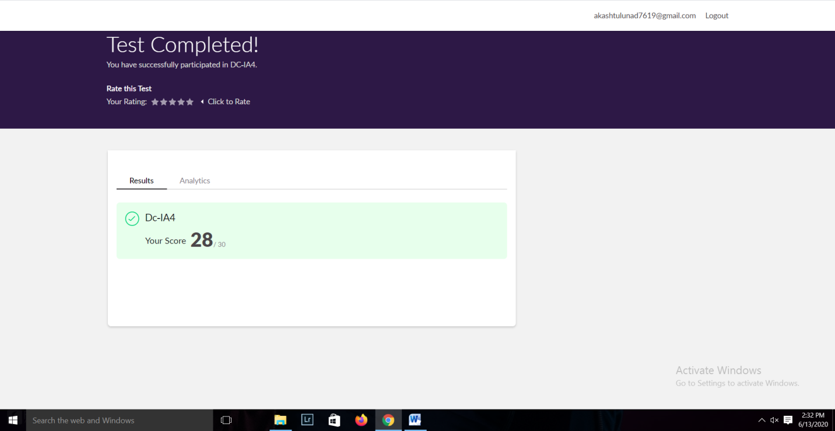

**Online Certification course:**

Today I have started a new course

Name of the course : Introduction to neural network and deep learning

Duration: 9.5 hours

Certificate provider: great learning

Snap shot:



In todays video I have learnt about Introduction to neural network, activation functions, feed forward neural network and back propagation and gradient desecent.

Online Coding summary:

1. **Write a c program to calculate the electricity bill**

